BCM Bible Study: February 10/11, 2021
Exodus 25:1-31:18; 35:1-40:33: The Tabernacle

Introduction: Last week we ended by focusing on the fact that God wants to know you and be with you. This is a great bridge into the tabernacle section, because we will see that this is the heartbeat of the ending of Exodus.

Before we step into the text, a few words of explanation are in order.
- The tabernacle section is huge. To read it in full is valuable, but it would take up too much time in our setting; we will read only pieces of it.
- The tabernacle section is split into two pieces. Chapters 25-31 detail the instructions that Moses received on Sinai. Chapters 35-40 describe the tabernacle being built. These sections are not exact copies of each other, but they are very close. In between is the golden calf incident, where Israel builds an idol. We will see that God’s desire to dwell with his people persists despite blatant rebellion.
- When we get to this section, we sometimes groan because it can be so tedious to read. However, the fact that the tabernacle spans 13 chapters means that it was very important, first for the ancient reader, and now for us. We have seen how Moses has left out many details that would have appreciated along the way. But here, no detail is missing.
- Interpreting the tabernacle can be difficult. As you look at different sections, it would not be helpful to ask, “What does the lampstand mean to me?” Instead, we will see that the structure of the tabernacle as a whole tells us how the people could be intimately connected to God. This will be our focus as we see this image carried into the New Testament.
- Finally, this Bible study will be structured differently than others. We will begin by trying to understand the theology of the tabernacle. Then, we will look at the New Testament’s discussion of it. We will end by considering application.

Section 1: Why a Tabernacle? Read Exodus 25:1-9
- What is the reason for building the tabernacle? (v.8)
- Read Exodus 25:10-22. What purpose does the ark serve?
  - Why is the idea of God wanting to dwell with his people significant in light of what we read last week about the impossibility of seeing God?

Watch Video #1: Understanding the Tabernacle. To understand the tabernacle, let’s consider a few themes: holiness, heaven on earth, and re-creation.
- What thoughts, questions, or reflections do you have after watching the video?

Let’s take a look for ourselves at how these themes show up in Scripture?
- Holiness: Compare the building materials in Exodus 25:10-13 and Exodus 30:17-18. What differences do you see?
  - What does it mean that God is holy? What does this mean for our interaction with him?
- Heaven on Earth: Take a lot at the intensity surrounding the event of entering the most holy place in the tabernacle: Read Exodus 28:31-38. The reason for such strict guidance is clear here in this passage - Read Exodus 29:42-46.
  - How does it impact you that God would go to such great lengths to be present with his people?
- Re-Creation: Read Exodus 31:12-18. What does God mean in verse 13 that he makes them holy? How is he doing this? (See video for more explanation.)
  - “The regular keeping of the Sabbath serves a purpose for our benefit, to help us along in a deeper understanding of who God is.” (Enns)

Section 2: The Tabernacle and the NT
Watch Video #2: Tabernacle into the New Testament
- What thoughts, questions, or reflections do you have after watching the video?

Let’s take a look at some of the verses and ideas mentioned in the video: Read Matthew 28:18-20, John 1:14, 1 Corinthians 3:16-17, 1 Corinthians 6:19, 2 Corinthians 5:17, Hebrews 4:14-16, Revelation 21:22-23
- Where do you see themes we have been talking about in these passages?
- Many of these passages may be familiar to you. How does looking at them through the lens of the tabernacle help you understand them in a new way?
- How does our understanding of the tabernacle shape how you think about Jesus and his purposes on earth?

Section 3: God in Us!
- Take a look again at 1 Corinthians 3:16-17 and 1 Corinthians 6:19. What does it mean that you are God’s temple? What should this mean for how you live your life?
  - It is important to note that God wants to dwell on earth. This means that creation isn’t bad; it is simply broken and marred by sin. What does this mean about the way you treat your body and creation in general?
- Take a look again at 2 Corinthians 5:17. “We are worthy of the Spirit’s indwelling because we have been re-created by the power of God into heavenly beings.” (Enns)
  - Does it strike you as odd to think of yourself as a heavenly being? What causes you to struggle to think of yourself that way?
  - As new creations/heavenly beings, we are called to be set apart. For Israel, this meant observing the Sabbath. We are called to live in a way that is a testimony to those around us. What might that look like?
  - A part of God’s design for his people is to live in loving community together. By doing so, they shine a light to the world. God’s community is, of course, the Church. Consider this quote: “Going to church is also a testimony to the chaotic world around us.” (Peter Enns)
    - What do you think of this quote? Is it difficult for you to go to church? Why? What are the most appealing parts of church for you?
- “The story of the Bible is nothing less than God’s initial intimacy with his creation, the severing of that intimacy, and the steps he takes to restore that intimacy. By living in us, by making us temples of his Spirit, he demonstrates that we are participating in the last chapter of the story.” (Enns)
  - What do you think about the idea that God wants an intimate relationship with you? Do you find it hard to believe? Easy to believe? Why?
  - What can you do this week to draw more closely to God?
Notes: Part of me wants to give lots of fun notes about all the things happening in this chapters. The other part of me knows I can’t do that. The following notes relate only to the passages you will read in this study. If you have questions about other things, feel free to reach out.
- Where did all these precious, expensive materials come from? In one sense, we are not sure. But it seems likely that this is a part of the “plunder” that Israel received while fleeing Egypt. It is very reasonable to think of the Israelites carrying this material since there were now millions of them.
- Acacia wood comes up a lot in these readings. It is a lightweight wood, perfect for making a transportable structure.
- The tabernacle and much of what is described here would have been common to people in the ancient Near East. In other words, God met with his people by means of structures and patterns they would understand. While it seems odd to us, it would have been a very common idea for them.
- Many have asked why the ark is presented first since it does not appear first in the section describing the construction. In my mind, the most likely explanation is that Moses is putting the first thing first – God’s presence, via the ark, is what this is all about.
- Arks were not uncommon in the ancient world, nor were the use of cherubim in religious imagery. It could be said that God was merely employing themes the Israelites could have understood. However, it seems more likely to me that people all over the world had experienced pieces of the same spiritual world. In other words, cherubim are real spiritual creatures (one appears in Eden in Genesis 3), so it is not surprising that many people across ancient cultures acknowledged them as such.
- An ephod is an apron-like garment. In 1 Samuel it evidently had something to do with discerning God’s will.
- Why the priest had to where bells is unclear. How do they prevent the death that is the punishment for not having them? It is popularly thought that the bells would serve as a means of knowing that the minister is still alive, but there is no evidence for this that I have seen! This one is a mystery!

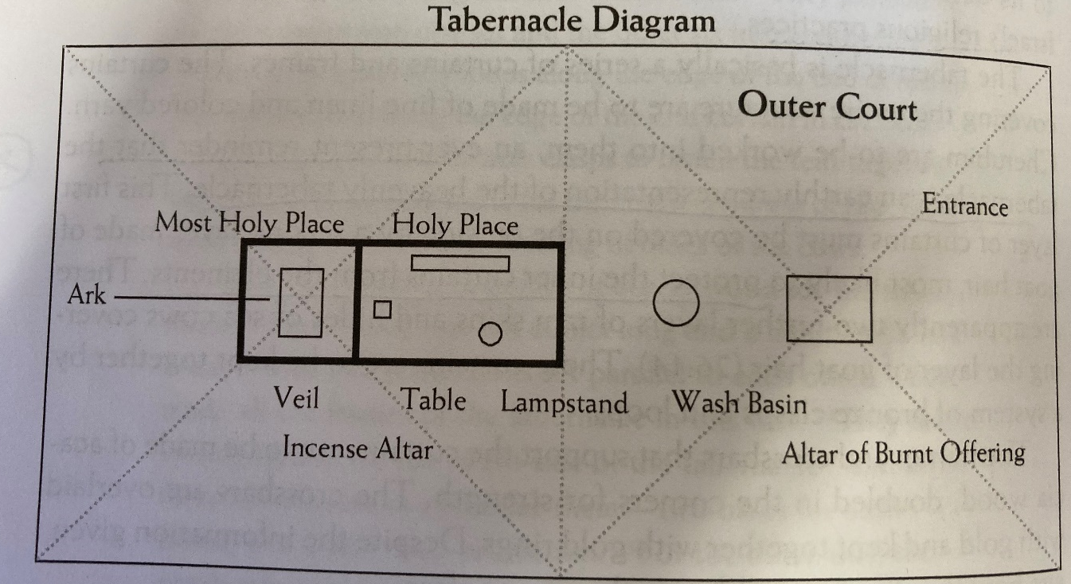
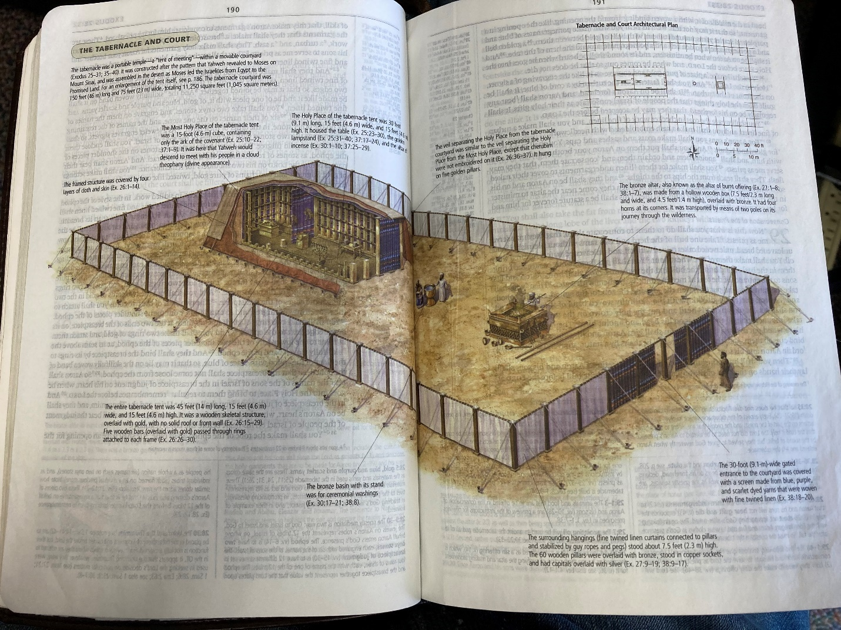

Notes for Video #1: Understanding the Tabernacle
Holiness: The tabernacle was made out of precious materials for a reason - the preciousness/sanctity of the material used corresponds to the sanctity of that particular of the area. The closer to God, the more precious the materials used. This principle is true for fabrics and even the detail of the craftsmanship. This communicates that there is no one like God – he is holy.

Heaven on Earth: If you look carefully at how the tabernacle is constructed, you will see that it is modeled after Sinai. There are three areas of increasing holiness into which only certain people are allowed. Just as Moses is only allowed into the most intimate setting with God on Sinai, only the high priest is allowed into the Holy of Holies where the ark resides.

The ultimate purpose of the tabernacle is for God to dwell with people. Since God’s presence is what makes heaven, heaven, God dwelling with his people means that he is bringing heaven to earth. It is interesting to note that as you get closer to the Holy of Holies, the curtains have more cherubim. These are angelic creatures who live in God’s presence. In the tabernacle we see “the desire of the Lord to dwell among his people, and the necessity of the tabernacle to that end.” (D.A. Carson)

Re-Creation:
While God wants to dwell with his people, he doesn’t merely do so on a whim. Instead, a careful reading of the tabernacle instructions will demonstrate that the tabernacle parallels God’s creation of the earth. There are several ways this connected is conveyed, two of which are: language and imagery parallel to Genesis 1-2 and the seven-day pattern ending in Sabbath. (Ex. 31:12-18) This means that the tabernacle is a new creation or a recreation, through which he will be present with his people.

This series of quotes shed light on the significance of this re-creation theme:
“Just as the Lord rules through establishing order and making distinctions in Genesis 1, so he rules through establishing order and making distinctions in the tabernacle…The tabernacle, then, represents all that the cosmos was created to be: the Lord ruling over the universe as king, with all creation in appropriate obedience.” (Carson)

“In the midst of a fallen world, in exile from the Garden of Eden – the original “heaven on earth” – God undertakes another act of creation, a building project that is nothing less than a return to pre-Fall splendor. The tabernacle, therefore, is laden with redemptive significance…because of what it is: a piece of holy ground amid a world that has lost it’s way.” (Enns)

“By building the tabernacle and setting apart one day in seven, God is truly creating heaven in space and time. By entering the tabernacle, Israel entered God’s house; by keeping the Sabbath, Israel entered God’s rest.” (Enns)

Notes for Video #2: Tabernacle into the New Testament
To understand how to apply this Scripture to our lives, we first need to recognize that the temple is the continuation of the tabernacle. The temple served the same purpose of the tabernacle, but it was a permanent structure. So when you hear Jesus talking about the temple or about us being the temple, you can think of the tabernacle.

When Jesus comes, he does something amazing. John 1:14 says that Jesus came to dwell among us. The word for “dwell” is the same Greek word used for tabernacle in the Greek Old Testament. So when Jesus came, he came to “tabernacle” with us. In him, God came down to be with his people. Christ is the fulfillment of the purpose that the tabernacle served.

We also see in the New Testament that Christ is our high priest. This priest doesn’t need to wear garments, his own character is enough to be in the presence of the Father. Like the high priest, he makes atonement for the people, but this time with his own blood.

When Christ ascended, something even more shocking happens – he sends the Spirit to dwell in us! We become the tabernacle! In doing so, like he made a new creation with the tabernacle, he makes us a new creation and dwells in us. In doing so, the presence of God is both renewing us and bringing heaven to earth, as we act on his behalf, together with him, wherever we go.

